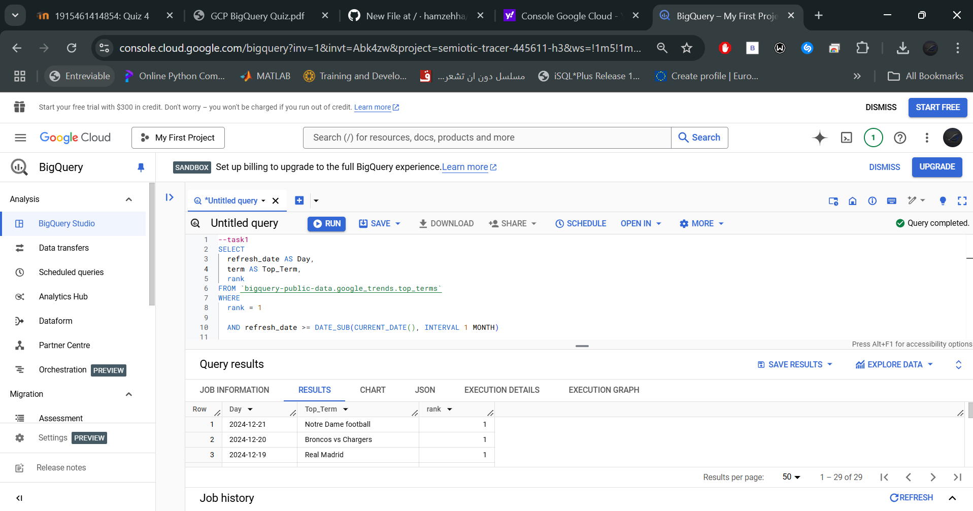

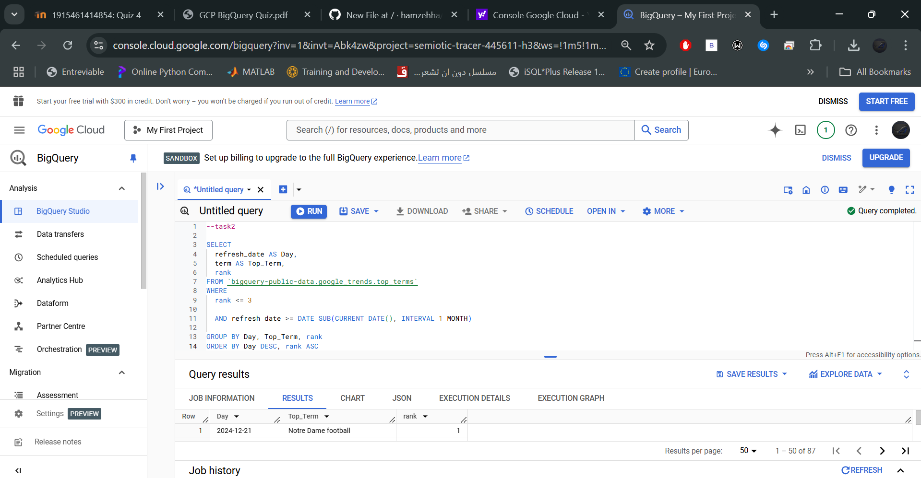

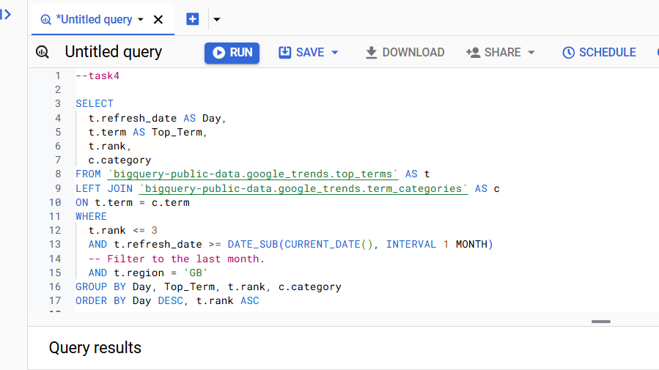

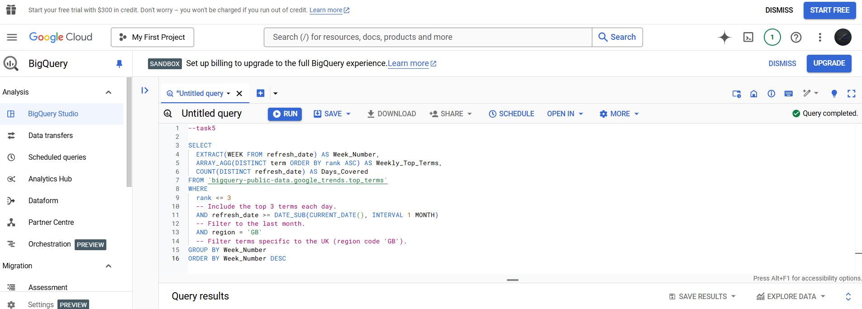

A brief explanation of the changes you made and how they impacted the output.

**Changes Made**:

Adjusted filters (e.g., date ranges, rankings, and regions) to extract more specific or comprehensive data.

Incorporated new functionalities such as regional filtering, joining additional tables, and aggregating data weekly.

**Impact on Output**:

Expanded the scope of the analysis (e.g., moving from 2 weeks to 1 month or from rank 1 to top 3 terms).

Provided additional insights, such as regional trends, term categories, and weekly patterns, enabling a deeper understanding of search behavior.

Enhanced the richness and granularity of the data output by including new dimensions (e.g., term categories) and broader filters.